Docker Task

Install docker on EC2 and explore the docker commands (docker images, containers, volumes, network)

Step 1. Launch a EC2 Instance.

Step 2: Install Docker.

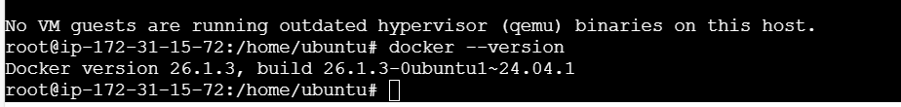

Step3: Docker commands

1. Docker images and Pull commands.

“Docker images” command will help you show the all the docker images

“Docker pull \*\*\* “ helps to download the docker image from the docker hub.

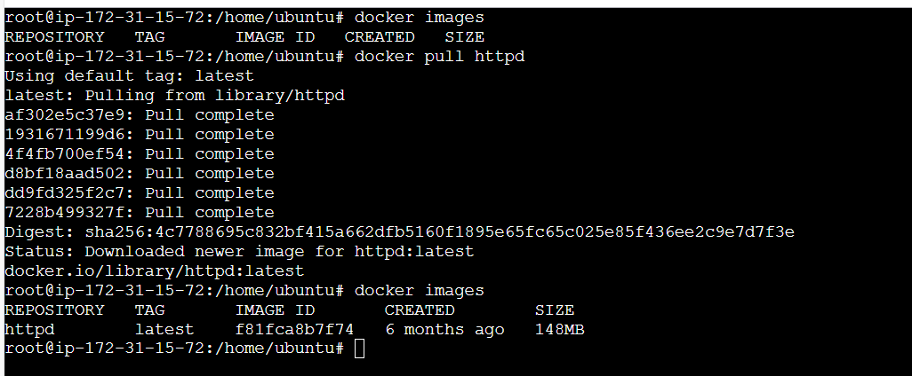

1. Docker run – To create a Container from the image

“docker run -itd -p “8080:80” httpd”

8080 port we assigning for the docker container and port 80 for httpd image

1. "docker ps” -> List the running Containers

“docker ps -a” -> List all the Containers

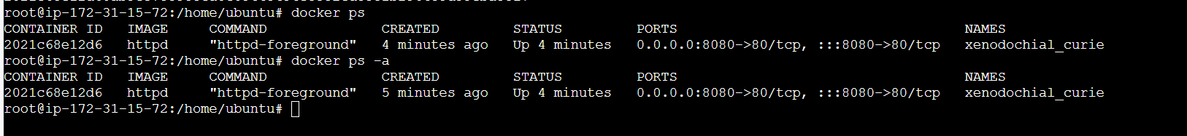

1. docker exec -it {Container id} /bin/bash -> To get into the Container

1. docker stop {Container id} - To stop the Container

1. docker start {Container id} - To start the Container



1. docker rm {Conatiner id} - To remove a Stopped Container

docker rm -f {Conatiner id} - To force remove a running Container

1. docker network create

1. docker volume.

